**GENERAL HUMAN BIOLOGY – YEAR 12**

**TASK 4 – MUSCULAR SYSTEMS TEST**

**NAME: ________________________________ WEIGHTING: 7.5%**

**DATE: ________________________________ MARK: ______ / 32 = ______ %**

***MULTIPLE CHOICE SECTION [5 MARKS]***

1. 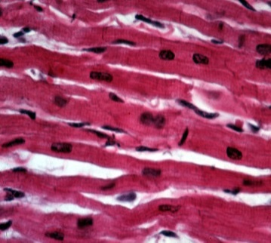A student examining a microscope slide of muscle tissue under the microscope saw the presence of striations and intercalated discs. The type of muscle he was looking at was:
2. Cardiac muscle
3. Skeletal muscle
4. Smooth muscle
5. Tendon
6. Which of the statement below is true of the image below?

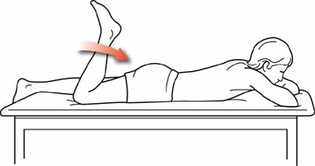

Hamstring

Quadriceps

1. To bring his foot towards his buttocks, the person must have contracted his quadriceps and relaxed his hamstrings
2. To bring his foot towards his buttocks, the person must have contracted his hamstrings and relaxed his quadriceps
3. To bring his foot towards his buttocks, the person must have contracted his quadriceps and also contracted his hamstrings
4. To bring his foot towards his buttocks, the person must have relaxed both his quadriceps and his hamstrings because neither of these muscles groups is involved in this action which is in fact performed by other leg muscles
5. Muscles are attached to bones by:  
   1. Cartilage
   2. Synovials
   3. Ligaments
   4. Tendons
6. Muscles always act:   
   1. Singly
   2. In pairs
   3. In threes
   4. Only when we think about them
7. Locomotion and balance is facilitated by the structure and actions of skeletal muscles. Muscles have three characteristics that facilitate their function, which are:
   1. Contractibility, flexion, agonist
   2. Extensibility, contractibility, elasticity
   3. Extensibility, hyaline, fibrous
   4. Smooth, cardiac, skeletal

***SHORT ANSWER SECTION [13 MARKS]***

1. The diagram below shows three types of muscle tissues labelled X, Y and Z

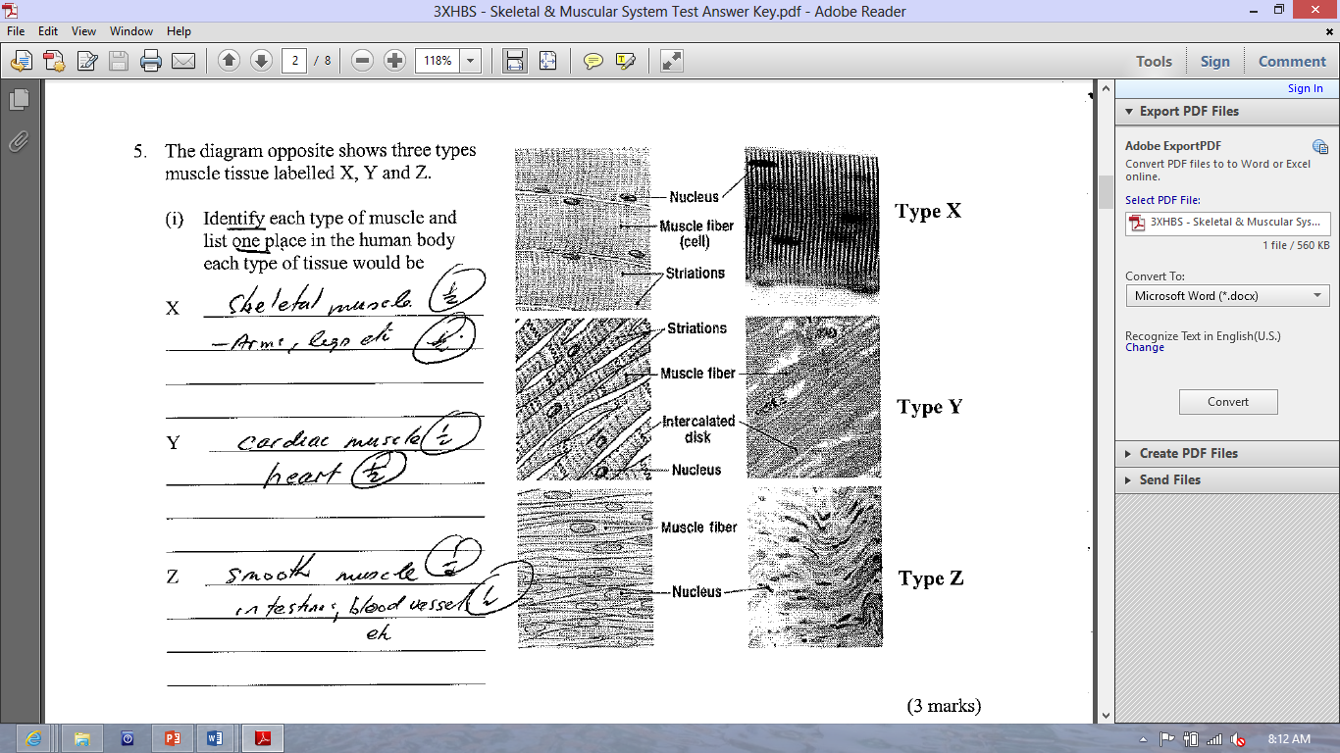

Identify each type of muscle tissue and list one place in the human body each type of tissue would be ? [3 marks]

1. Muscle X: ___________________________________________________________

___________________________________________________________

1. Muscle Y: ___________________________________________________________

___________________________________________________________

1. Muscle Z: ___________________________________________________________

___________________________________________________________

1. The diagram shows Sally lifting weights from below her hips to a position directly above her head:



1. Name the term to best describe her arm movements as she raises her arms above her head ?

[1 mark]

1. Below is a diagram of someone raising their forearm towards their shoulder. Label the following terms on the diagram: [2 marks]  
   * *Agonist, antagonist, belly, origin, insertion*

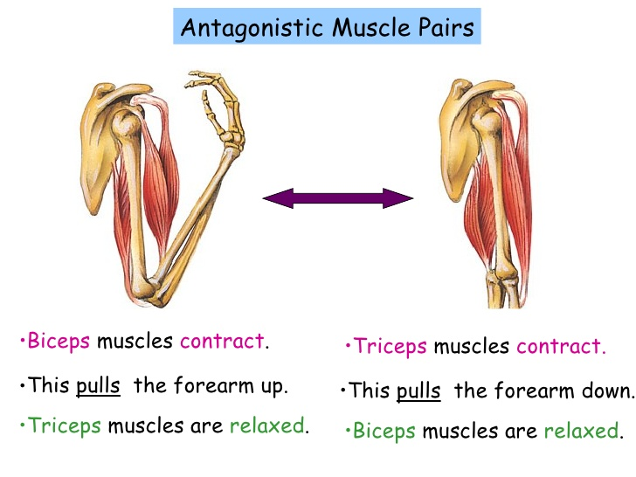

1. Explain, using the movement shown in the diagram above, what is meant by the statement that “skeletal muscles are arranged in antagonistic pairs with the support of synergist muscles”? [3 marks]

____________________________________________________________________________

____________________________________________________________________________

____________________________________________________________________________

____________________________________________________________________________

____________________________________________________________________________

____________________________________________________________________________

____________________________________________________________________________

____________________________________________________________________________

____________________________________________________________________________

____________________________________________________________________________

1. Below is a diagram of muscle structure.  
     
   Label the following diagram on muscle structure. [4 marks]

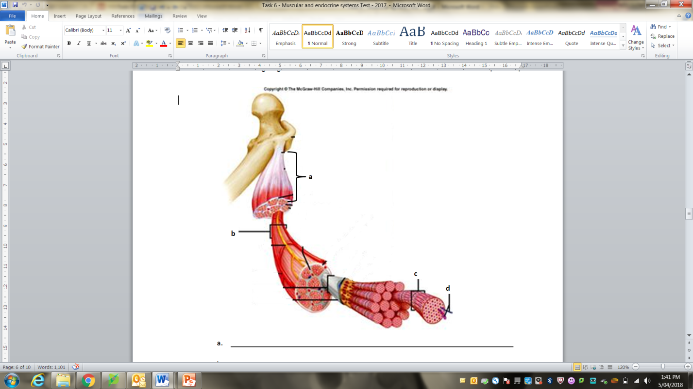



***EXTENDED ANSWER SECTION [14 MARKS]***

1. Muscular strength and fibre type is related to the ability to balance the body in a set position. While maintaining a set position when balancing, the muscles have to be able to sustain a set level of contraction to keep the position. They do this by alternating the amount of contraction in each muscle fibre, relaxing some and contracting others. The ability to maintain a set varies between individuals.

**AIM**

To determine your ability to maintain a state of equilibrium (balance) in a static (stationary) position.

**MATERIALS**

* Open are with hard floor
* Stopwatch

**PROCEDURE**

1. 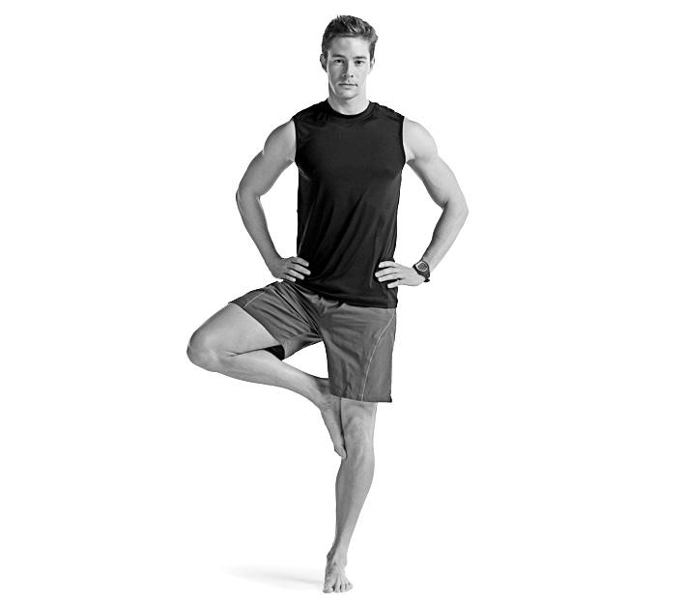Remove shoes/socks.
2. Stand comfortably on both feet.
3. Place your hands on your hips.
4. Lift one leg and place the toes of that foot against the knee of the other leg.
5. Raise the heel and stand on your toes.
6. Start the stopwatch.
7. Balance for as long as possible without letting your heel touch the ground or the other foot move away from the knee.
8. Record your time.
9. Repeat on other leg.
10. Determine your average and compare to the table of norms for 15-17 y.o. athletes.

**RESULTS**

Balancing time for right leg: ________________________________

[1 mark]

Balancing time for left leg: _________________________________

[1 mark]

Average: ____________________________

Show working out for average calculation in the space below: [2 mark]

The following table is for 15-17 y.o. athletes:

|  |  |  |  |  |
| --- | --- | --- | --- | --- |
| **Excellent** | **Above Average** | **Average** | **Below Average** | **Poor** |
| >50 secs | 40-49 secs | 26-39 secs | 11-25 secs | < 11 secs |

1. How did your average compare to athletes of your age range? [1 mark]
2. What type of muscle tissue would be used to perform the stork stand? [1 mark]
3. Why do you think the body does not contract all muscle fibres at the same time when balancing or holding a position for an extended period of time? [2 marks]
4. Contraction of muscles can be seen at the microscopic level. The functional unit of a myofibril is called a sarcomere. In the space below:
   1. Draw and label a diagram of a sarcomere. Include *actin, myosin* and *Z-line* [3 marks]
   2. Explain how contraction occurs in a sarcomere [3 marks]

***END OF TEST***